LangChain Chains
24.06.2025

Langchain Chains
Think of them as pipelines where each step can involve calling a language model, transforming data, or interacting with tools like databases or APIs.
Using the chain output of one task is input for the next task implicitly reducing lines of code.

We have 4 types of chains:
- Simple Chain - its a simple chain just a task to do.
- Sequential Chain - when we require 2 LLMs to do different works and merge them.
- Parallel Chain - when 2 different works parallely going on using different models and merged using a chain.
- Conditional Chain - either branch one or 2nd is fulfilled based on output by classifier chain.

Langchain Runnables
We need runnables because different component of doing a task have different properties that cannot be used in one chain

E.g. PDF Reader
PDF load —-> Text Splits —-> Embedding —--> Vector store —--> Retrieval —---> LLM —---> Parse
Alongside LLM we have these many different components and for all of them we want to put them in functioning using a single chain but that is not possible because of the different standards they follow.
Prompt component uses - format function
LLM - predict function
Parse - parse function

So first all different components are created by the same abstract class so they all have the same “invoke” function they inherit from the parent abstract class. Now Chains can be applied to them even now two different chains also can be connected i.e. 2 workflows can also be connected called runnable.
Each workflow is now runnable.

Types of Runnables :
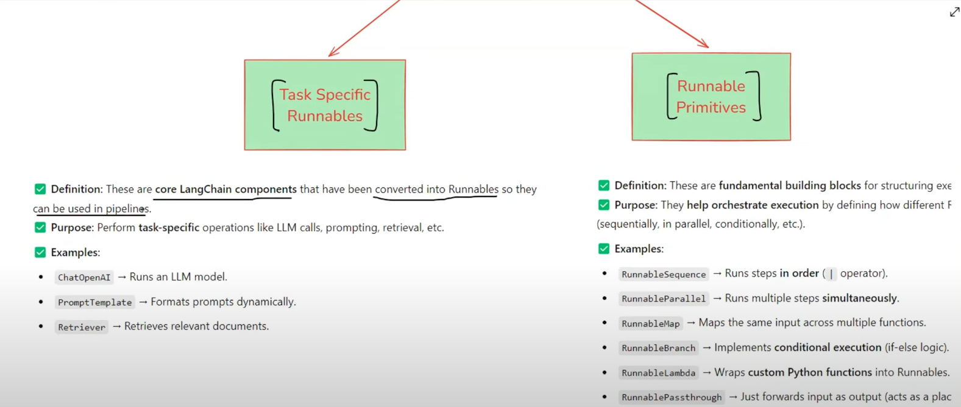
Task Specific Runnables are those that are for specific tasks like LLM , Prompt , parser etc. Different components are converted into runnables so that they can be used in pipelines.

Runnable Primitives are those that connect different runnables into pipelines so that we can form even more complex chains if required.

Different Runnable Primitives
RunnableSequence - to make a simple chain connecting different components.

RunnableParallel - allows multiple runnables to execute in parallel . Each runnable receives the same input and independently produces a dictionary of outputs.

RunnableBranch - conditional chains , either any of the branches is going to give output. If no condition matches there will be a default runnable.

RunnablePassthrough - returns the input as output without modifying it.

RunnableLambda - allows the application of custom python functions within an AI pipeline.

